Legacy of Longfields

  - SPRING 2017
Project Newsletter
This newsletter aims to bring you up to date with project activities and is produced quarterly. If you would like to contribute to the newsletter, project blog or have ideas for project activities then please forward your suggestions to Teresa Hillier.

Project blog:
legacyoflongfields.wordpress.com

Twitter
@Longfields1952

Teresa Hillier is the project manager and was employed at Longfields from 1999 to 2004. Teresa is part of a team that made a successful Heritage Lottery Fund application. This application highlighted the fact that only limited formal research had been undertaken on the Association and there was a danger it would be forgotten following its closure.

Project Activities

Oral history training took place on Monday 30th January at the Environment Centre in Swansea. Dr. Beth Thomas from the Oral History Society provided the training; she is based at the National History Museum, St Fagans. On the day we covered topics including understanding memory, the practicalities of interviews and question preparation. We also discussed consent and copyright and then had a practical session using recording equipment. There was lots of useful information to take away from the day and put into practice.

The project website is currently being developed with Jon Hurley of Jonathon Hurley Graphic Design Solutions. The objective is to launch the website within the next couple of months once all the content has been agreed. A preview of the front page can be viewed on Jon’s blog at http://www.jhurleydesign.com/blog-2/

Memory gathering events have been held at Swansea Vale Resource Centre in Llansamlet. Several of the people who went to Longfields now attend this centre. It has been great to share memories, look at old photographs and remember Longfields. A big thankyou to Andy Price at the Resource Centre for making this possible and of course, to everyone who has contributed. Special thanks also to Sharon Humphreys and Pat Payne for giving up their time to volunteer. The outcomes from these events are currently being reviewed and will form part of the project exhibition next year.

An increasing archive of newspaper cuttings has been gathered and lots of interesting stories are being uncovered. Longfields has had a lot of press coverage over the years and this archive complements the history contained within the Association’s Year Books.

Contact has been made with family members, ex staff members and others with links to Longfields. Over the coming weeks all of these people will be contributing to the project by sharing their memories. Many thanks to all for the interest shown and the time given by participating. It is much appreciated and so valuable for the project research.

Work with Pen Y Bryn School will be starting in April when they will be learning about the history of Longfields and about disability history. As part of their activities, visits have been planned to the Richard Burton Archives, The Egypt Centre and West Glamorgan Archives. Thank you to everyone for making this possible, we are all looking forward to these visits. We also have other activities and learning experiences planned which will be reported on in the next newsletter.

Forthcoming activities
- Continued recruitment of volunteers
- Oral history interviews
- Continued project research
- Archive visits with Pen Y Bryn School

Extract from Scout Troop report

Activities of Our Scout Troop
by Colin Rand (Scoutmaster)
Richard Paton and Huw Williams were able to camp under canvas for the first time. They attended the Whitsun Camp of 30th Swansea Scout Troop, held at Wernfadog, Ynystawe. Richard also camped for 10 days at Kinsham, Herefordshire, with the 30th and 42nd Swansea Scout Troops during August, 1962. The troop also thoroughly enjoyed a visit to Swansea Docks to see the Dutch Naval Squadron.

During the year, we were represented at most of the Scout functions held in the town, while Richard Paton represented us at the Scout/Guide Conference held at Swansea University.

Source: 1962/63 Association Year Book
West Glamorgan Archives

Extract from Scout Troop report

Active and Busy Year for Our Scout Troop
by Colin Rand (Scoutmaster)
Through the generosity and kindness of the Association in making us a gift of a bus we were able to take a number of scouts on visits to Scout Camps in Gower last August. “Bob-a-Job” week proved very successful and as a result we were able to purchase a Totem Pole for the Cubs.

The Scouts and Cubs, in company with all the other packs and troops attended the divisional St Georges’ Day parade held at Pantygwydr Church. The Cubs also attended the Cub Grove competition held at Scout Headquarters, Bryn Road in October. The Christmas Party this year was a combined function with the 30th Swansea (Hill) Scout Troop and the 1st Cockett Guide Company at the Children’s Home, Cockett.

Source: 1961/62 Association Year Book
West Glamorgan Archives

2nd Swansea Grove Scout Group

Did you know that Longfields had an active scout group? This was the 2nd Swansea Grove Scout Group and there were six boy Scouts and five Wolf Cubs. They met every Friday evening at Dumbarton School in Swansea and the BP Guild of Old Scouts, Rotary Club and Round Table worked a rota system to transport the members from their homes to their meetings. The group was registered with the Scout Authorities and in 1958 they purchased their own Troop Flag and won the Herbert Levick Award. This Award was given to the Scout Group who 'put the best effort into Scouting during the year'. As a group, they made links with other active Scout Groups and special mention was given to the 30th Swansea (Hill) Scout Troop and the 1st Cockett Girl Guide Company. Richard Paton from Longfields was awarded a First-Class Badge and was one of the first members of the group to achieve this.
Source: 1959/60 Association Year Book
West Glamorgan Archives

Extract of the tribute to the Scoutmaster Colin Rand (1967)

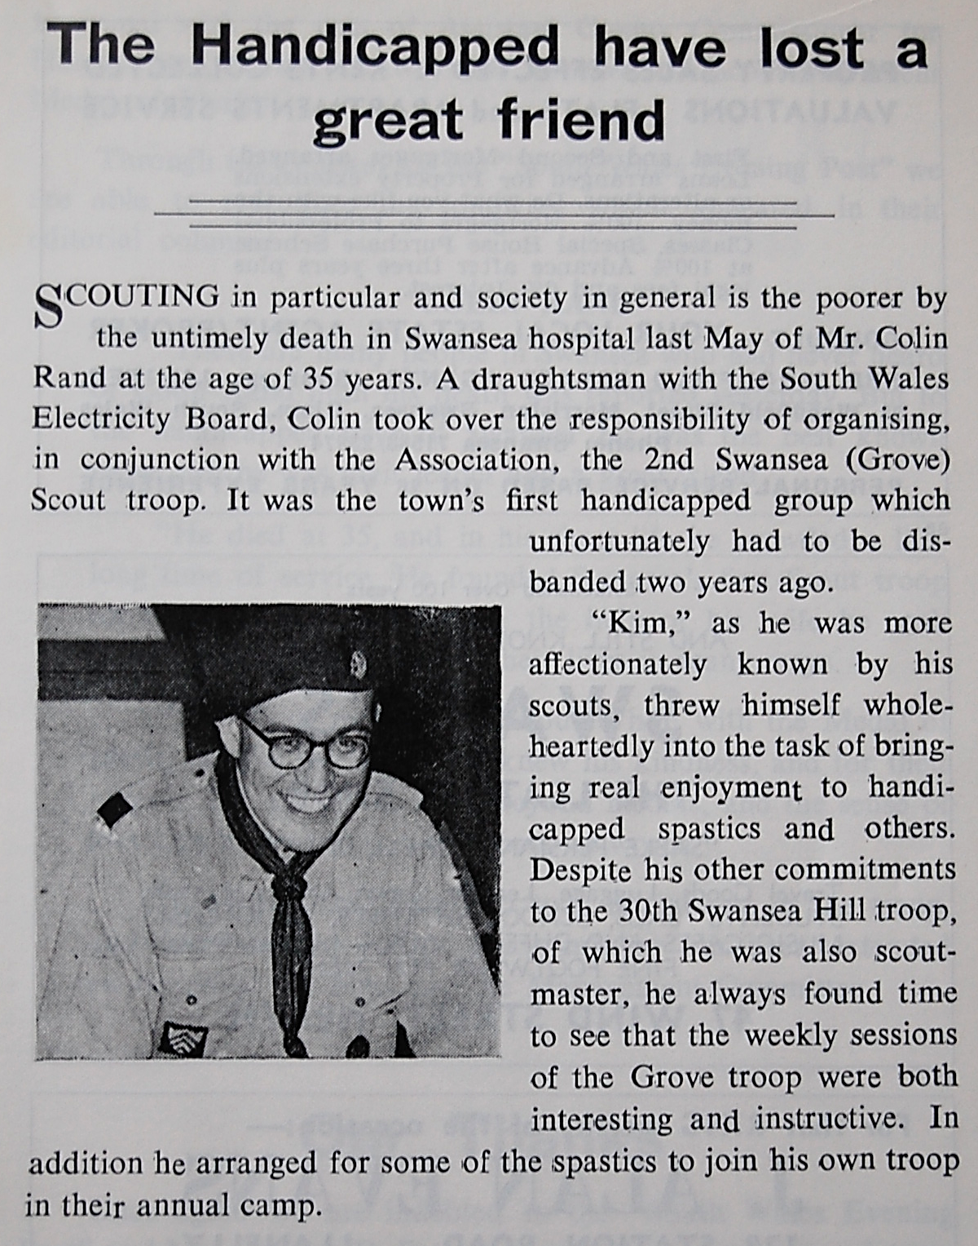

Enjoy the Easter holidays and remember if you would like to contribute to the newsletter, project blog or have ideas for project activities then please forward your suggestions to Teresa Hillier.

